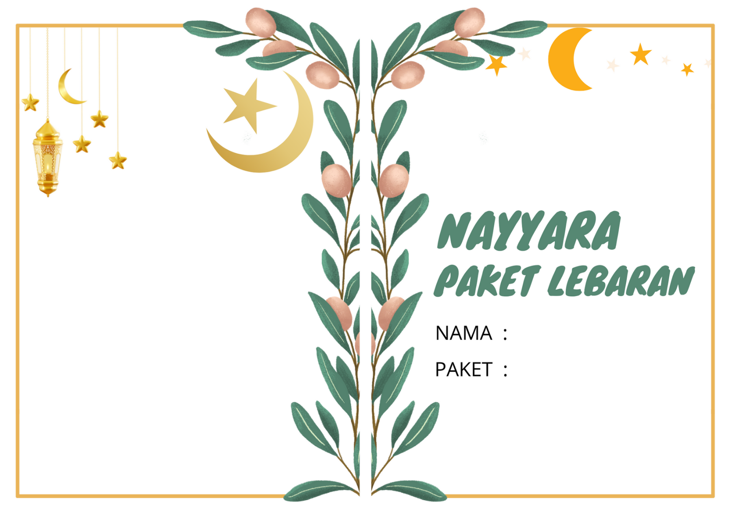--1

|  |  |  |  |  |  |  |  |  |  |
| --- | --- | --- | --- | --- | --- | --- | --- | --- | --- |
| 1 | 2 | 3 | 4 | 5 | 6 | 7 | 8 | 9 | 10 |
| 11 | 12 | 13 | 14 | 15 | 16 | 17 | 18 | 19 | 20 |
| 21 | 22 | 23 | 24 | 25 | 26 | 27 | 28 | 29 | 30 |
| 31 | 32 | 33 | 34 | 35 | 36 | 37 | 38 | 39 | 40 |
| 41 | 42 | 43 | 44 | 45 | 46 |  |  |  |  |